**Women’s Premier League 2023**

The shortest form of cricket is the most favoured one by all cricket enthusiast. In cricket crazy India, where people yearn for more cricket, where cricket is religion, where cricket is known to unite people of all sect, Women’s cricket cannot be far behind. Women’s cricket is growing day by day. First, we had the Under-19 T20 World Cup for women in South Africa followed by the T20 World Cup for women, again in South Africa and now the Women’s Premier League that is organised in India. **Thetidke** is one amongst the most effective [best online sport shop in india](https://thetidkes.com/) with a large range of all sports equipment and accessories online at best price. with The Indian Premier League for women, is popularly known as WPL. Fifteen years after the first Indian Premier League for men, Women’s Premier League is going to be held in Mumbai with five teams.

**Cricket Carnival**

This is of course, going to be a cricket carnival. It is scheduled for March 2023. It is said to have registered a total 1525 players for the inaugural Women’s Premier League Player Auction was pruned to 409. Ninety cricketers were up for auction on 13th February 2023 for the first ever Premier League in India. [**Thetidkes**](https://thetidkes.com/) having best cricket equipment online at best price. You will get best English willow cricket bat, [SS Kashmir Willow Cricket Bat](https://thetidkes.com/product/kashmir-willow-cricket-bat/) online only at Thetidkes. Players from England. Australia, Sri Lanka, West Indies, New Zealand, South Africa, Thailand, Singapore and Bangladesh will also be seen playing in the WPL 2023. Top players from different countries will be alongside other countries top players. The huge flow of money at the auction for women cricketers shows the interest and belief in the talent and skills shown by the women cricketers. This will surely bring in the spectators, sponsors, advertising agencies, media personnel’s, sports journalist and all other cricket related people flocking to Mumbai to be a part of the success story. The first ever Women’s League matches is -

**Scheduled for**: 4th March to 26th March 2023

Edition: First

Format: Twenty20 cricket

Number of teams: 5

Tournament format: Round-robin and playoffs

Number of games: 22

Organiser: BCCI

**Venue**: Mumbai

1. DY Patil Stadium
2. Brabourne Stadium

**The teams:**

Five teams are scheduled for the first Women’s Premier League.

1. Royal Challengers Bangalore
2. Mumbai Indians
3. Delhi Capitals
4. Gujarat Giants
5. Lucknow Warriors

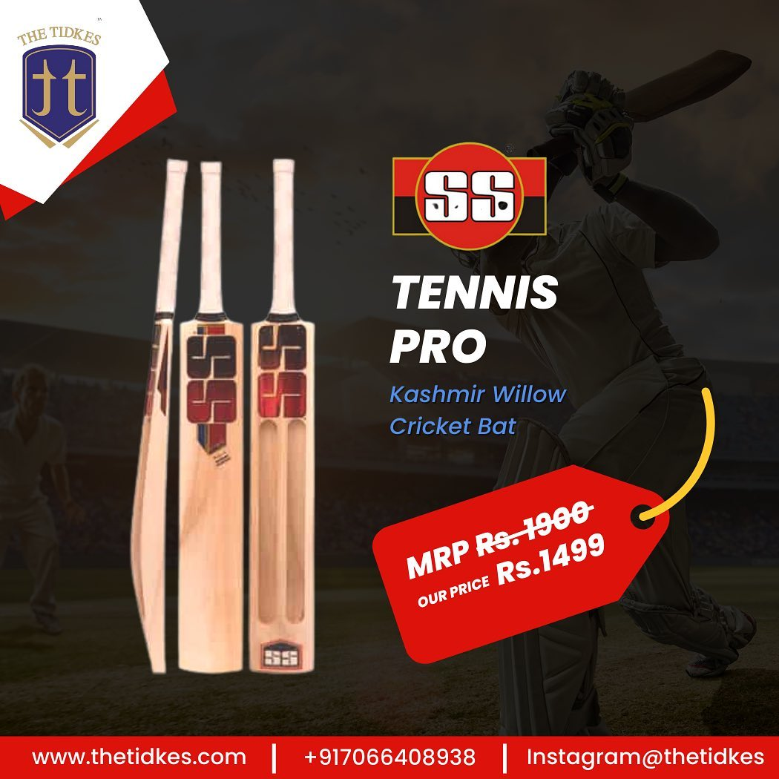

Each team is permitted to have 5 overseas players in their playing team of 11 players for each game but only if one of these players, is from an associated nation. The total number of players in each team would be 18.

**Match schedule for WPL**

The grand opening of the first ever WPL will be held at DY Patil Stadium. There shall be 20 league matches and one eliminator that is scheduled for 24th March and the final is scheduled for 26th March at the Brabourne stadium. The first match will be played between Mumbai Indians and Gujrat Gaints at Mumbai’s DY Patil Stadium. Indians are going to love it.

The BCCI has decided to pay the same match fees to the women as the men. These players are bought by their franchise owners for a huge sum. At last, women players are getting the respect that is due to them in all aspect of the sports. This is sure to encourage many young girls to make cricket their career and take up other jobs related to cricket. It is bound to encourage sports manufacturers to increase their stock of cricket related equipment and accessories. The fame and recognition enjoyed by cricketers in India is nothing less than film stars. So, you will find many youngsters trying to emulate their stars and hoping to become cricketers. A chain of jobs will now be added in the field of cricket. Coaching and training for cricket related jobs is going to be the most lucrative career.

All young girls can have their pick, of the best bat and ball from [Thetidkes](https://www.thetidkes.com/) and fulfil your dream of becoming the best cricketer. We, at ‘**THE TIDKES’** would like to help you choose the best sports equipment.

You can collect your best cricket bat online from [Thetidkes](https://thetidkes.com/). So go ahead and get the best quality [cricket equipment](https://href.li/?https://thetidkes.com/product-category/cricket/) online from our e-commerce site at a reasonable price. Thetidkes is one of [best online sport shop in india](https://www.thetidkes.com/) that provides original and authentic products. Best sporting brands are also available at the best prices. Thetidkes has the best quality English willow cricket bat and Kashmir willow cricket bat online at an affordable price and even you can have a combo pack also. We have authorized distributors of Cosco, Yonex, Nivia, Spartan, SS, TT, Tennex, Konex and many more Indian and global brands. All sports products and accessories related to Cricket, basketball, volleyball, football, and table tennis are available at THE TIDKES.

You may also visit our website and buy online best quality sports equipment and accessories related to cricket, football, basketball, badminton, volleyball and table tennis.Carom boards, chess boards, yoga mats and skipping ropes are also available with ‘[THE TIDKES](https://thetidkes.com/shop/)’. Do visit our retail store, TT SPORTS, at Akola, Maharashtra to find a wide range of sports products and accessories. We are authorized distributors of Cosco, Yonex, Nivia, Spartan, SS, Tennex, Konex and many more Indian and global brands.

**You can contact us through social media.**

Instagram: [@thetidkes](https://href.li/?https://www.instagram.com/thetidkes)

Facebook: [Tidke Exporters and Traders Private Limited](https://t.umblr.com/redirect?z=https%3A%2F%2Fwww.facebook.com%2Fthetidkes&t=ODRkNDQwZDNiNjJlYzVmYzA5NzFjYjQwNGE2NjE0NDJlN2RmMjRhNixhMTU3Yzg0YWU4OGIzNzZmZjVjMDFmYTA5NGRlMzIyMzU2MmQ2ZTQ1&ts=1671786578)

.